Data is not something designers need to fear. In fact, it is quickly becoming an essential element of all creative industry practices. Whether you work as a freelancer, run your own business or work with a large international company; data-driven insights resulting from market research can improve your design work and help you to meet the needs of your customers more effectively.

The main purpose of market research is to identify patterns in trends and consumer behaviour. This means collecting data about consumers and analysing this information to help business

owners and other professionals understand the needs of a particular market which in effect lead to better commercial decisions. Market research is one of the most effective ways creative

industries can identify upcoming trends and respond to changes in consumer needs.



Fig 1. Pexels (n.d.) Identifying consumer behaviour is vital for effective marketing

## Doing market research

Market research is conducted using primary and secondary research. It is then interpreted

and critically analysed to produce consumer insights. These insights can be used to:

* Decide which projects to focus on
* Influence design choices for upcoming projects
* Identify customers and potential customers for a particular product or service
* Identify and implement new trends and changes to existing trends
* Create and adapt products and services in response to customer feedback
* Make decisions about how a finished product or service will be marketed and sold to customers

### Primary market research

#### Surveys

Surveys are the most well-known type of primary market research. They are a great tool for

gathering simple information about consumer activities e.g. “how often have you bought

clothes online in the past three months”, “which life events you typically arrange a photographer for”, or “what is the most important factor you consider when buying accessories for your home.”

Surveys can be completed in person, over the telephone or online. There are a number of websites that allow you to create and share your own surveys for free (e.g. Google Forms and Survey Monkey).

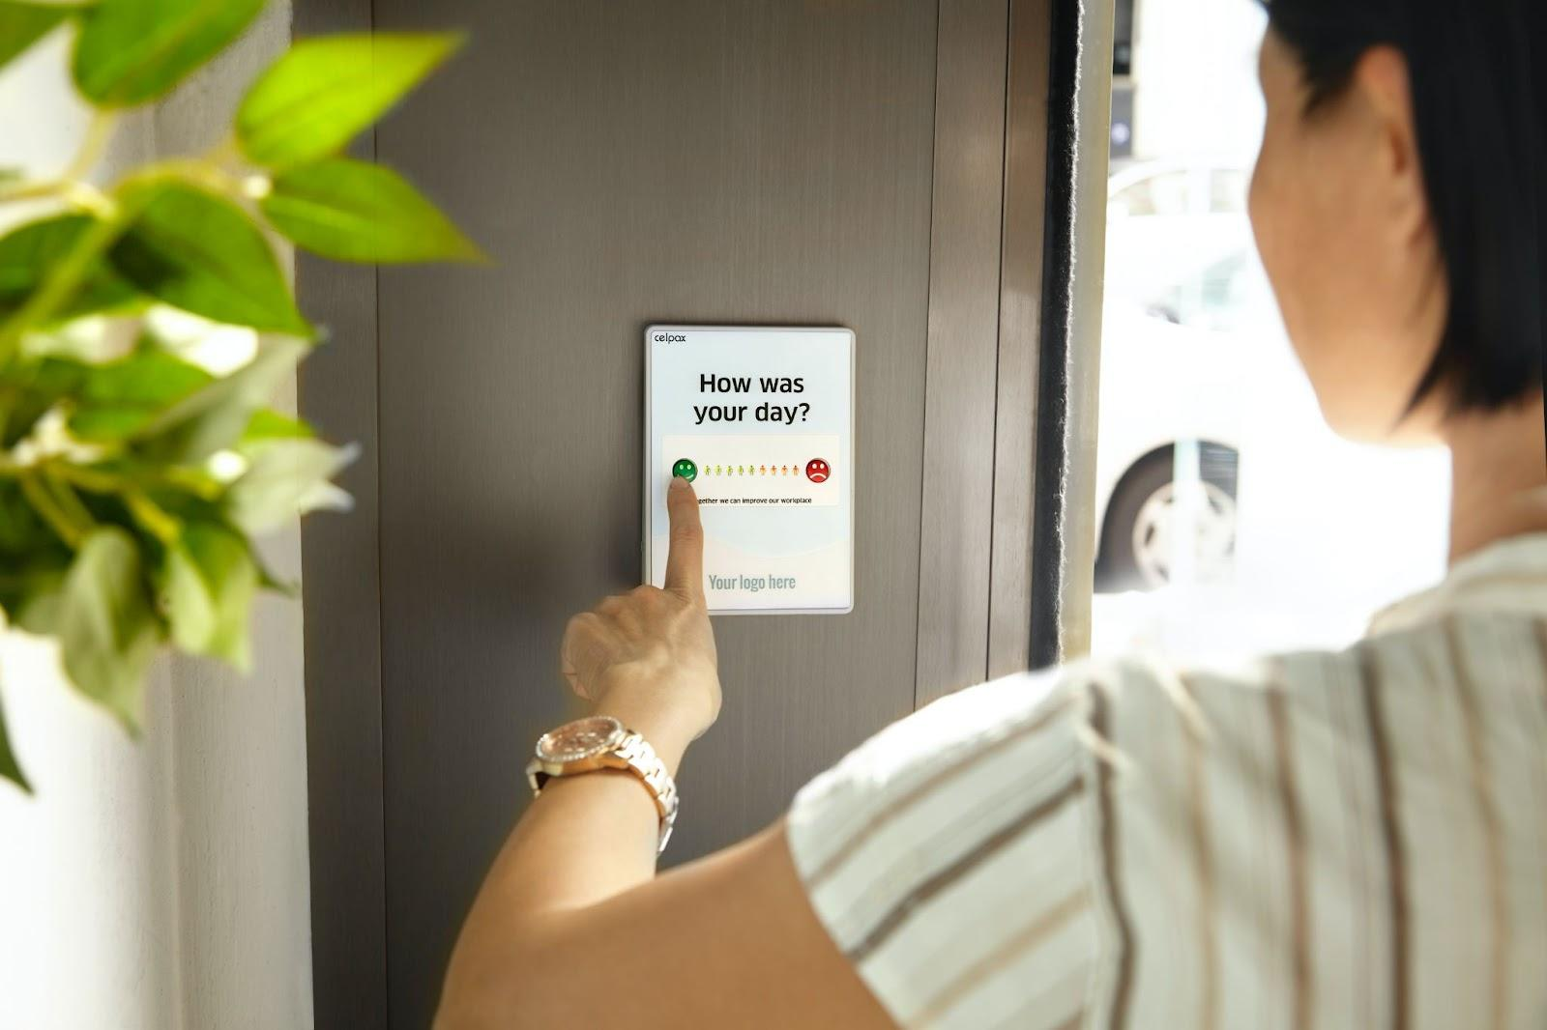

Fig 2. Unsplash (n.d.) Surveys can take many paper-based on digital forms

You need to be careful who you survey as you want to target consumers who are likely to

need your product or service. For example, a fashion designer specialising in luxury

sportswear is likely to need information about people who regularly engage in sports and

other fitness activities. At the same time, you don’t want to be too specific about who you

survey because you could lose important information about consumer needs. For instance, if you only survey people who go to the gym every day you could miss important information about others who wear sportswear for comfort and to express their own style. Such information could have a strong impact on your designs and business choices.

#### Focus groups

Focus groups are used when you want more in-depth information about consumer

attitudes. They bring a small number of people together in a room where a moderator asks

questions and oversees a detailed discussion. Focus groups normally last for one or two

hours but you may have to conduct a few sessions to get all the information you need.

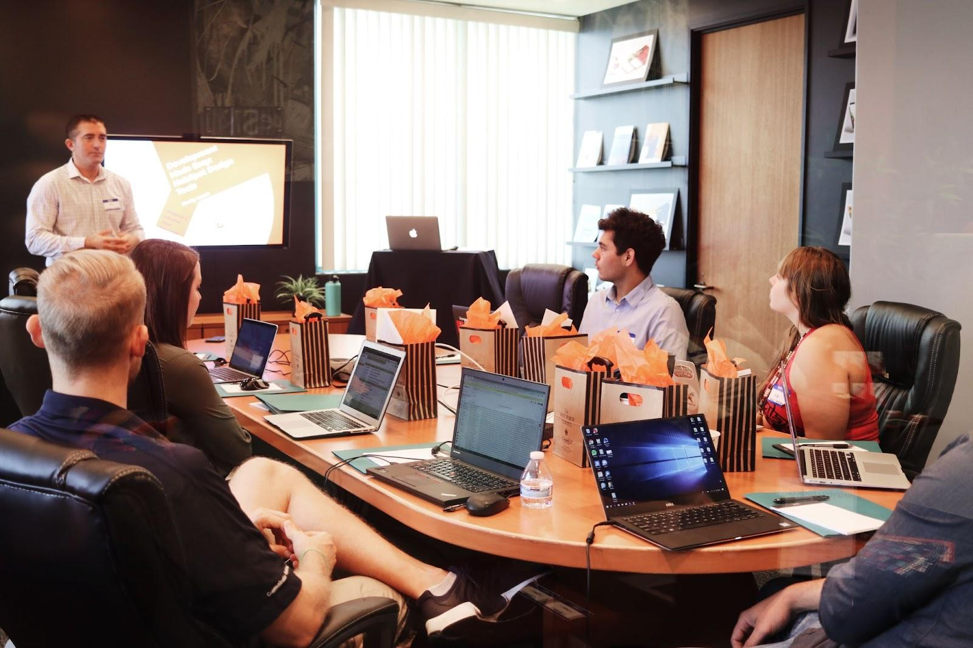

Fig 3. Unsplash (n.d.) Focus group session

#### Interviews

Interviews are similar to focus groups but are completed one on one and usually in person.

They are useful for uncovering attitudes towards a new product or service or for identifying

problems with items so that they can be improved before being made widely available.



Fig 4. Unsplash (n.d.) Interview

#### 

#### Observations

Observations focus on observing people in action, for example, at work, in a store, or at home, to better understand their behaviour and preferences. Sometimes what people say in surveys and what they do in practice are different. Seeing how people behave and interact in a particular space, with specific products and services, or in a natural setting can create important insights about their habits and patterns.



Fig 5. Unsplash (n.d.) Observing shopping habits can produce rich data

### Secondary market research

#### Reviewing data

Reviewing data that has been published by others is central to secondary market research.

It is used to understand current trends, identify competitors and analyse patterns in consumer attitudes. Common resources of secondary market research include trend forecast reports, articles from magazines and industry journals, social media comments, census data and market statistics produced by research agencies. It can take time to gather, read, document and critically analyse these resources so it is important to give yourself plenty of time to conduct your research.

#### Visual research

Visual research is a specific form of market research that is valuable to the creative industries. It’s a method that uses visual resources to develop consumer insights. It uses photographs, diagrams, timelines, maps, videos, drawings, material samples, colour samples and collages to draw conclusions. **Primary visual research** is where you visit different locations, take photos and sketch images to create insights. **Secondary visual research** is typically more common. This is where you examine and critically analyse images from forecasting agencies, industry competitors, social media channels, and perhaps ‘street fashion’ by reviewing fashion blogs and Instagram accounts for example.

## Ethics in market research



Fig 6. Unsplash (n.d.) Ethics should take priority over all else in research

When conducting primary market research, it is extremely important to respect and protect

the privacy of all participants. You should never share anyone’s information without first receiving permission in writing. The first step before interviewing, observing or surveying is to ensure the volunteer signs a consent form allowing you to use the information you collect for specific purposes. You should always be open and honest about how you plan to use the information you collect. Any information you publish should be anonymous, never using names or any other identifying factors. Also, your research should never cause any psychological, financial or social harm to your participants.

In secondary research, you must acknowledge and credit the original creators of any resources you use. Passing another person’s work off as your own is plagiarism. Use the Harvard

Referencing System for all resources you gather during secondary research.

## Analysing the data

After collecting all the information from your market research, it should be properly analysed to ensure it can be useful enough to influence any action. How the data is organised is up to the designer or marketing team. It may be categorised by geographical location, age, gender, etc. As long as it makes sense in terms of its purpose, your target market and competition.

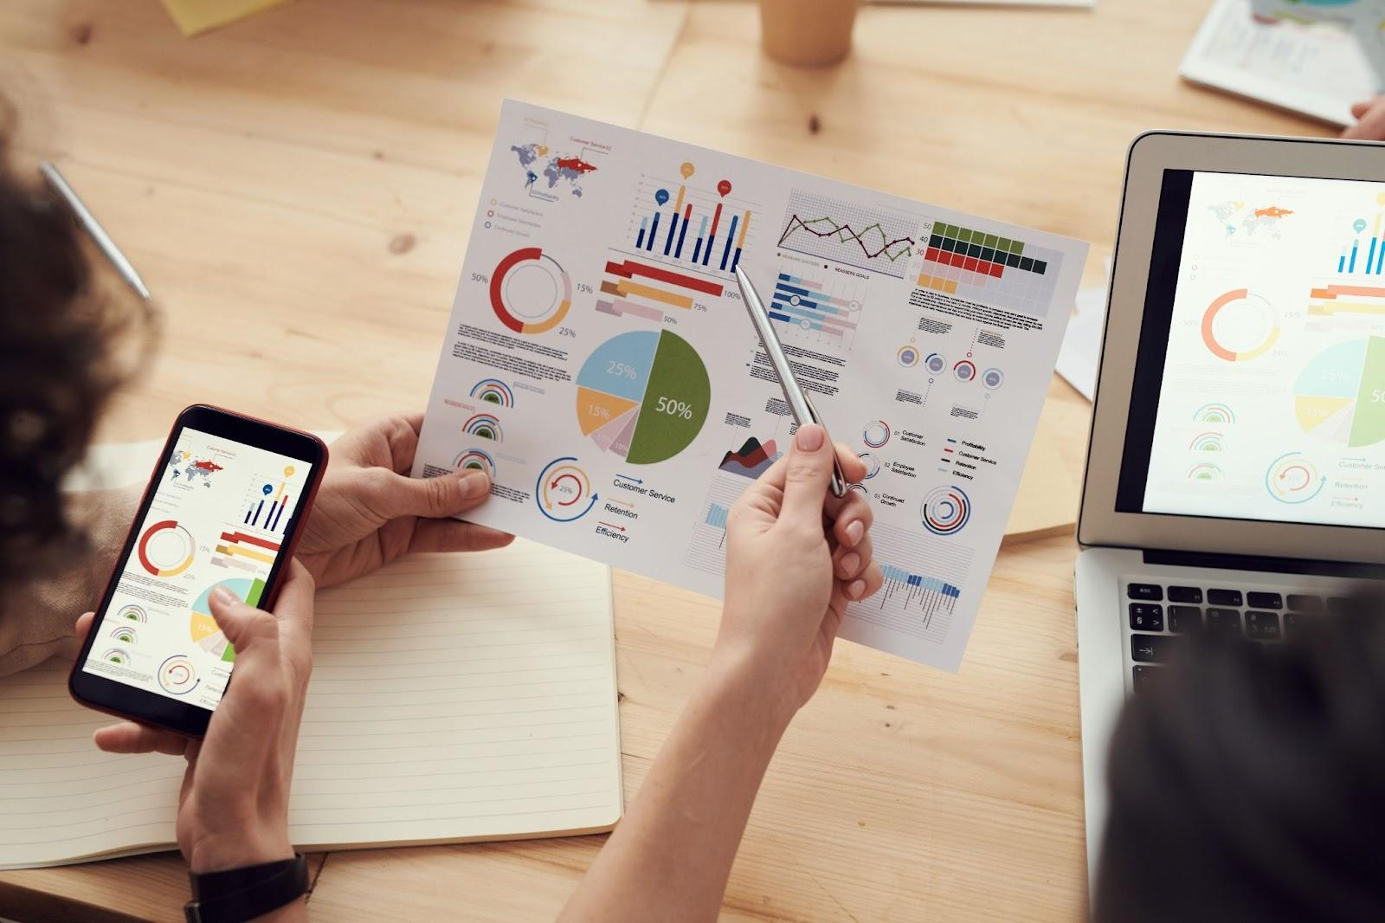

Fig 7. Pexels (n.d.) Present findings data in an easily congestible manner

Depending on your research aims, after examining the data in detail you should be able to summarise and outline much of the following information (Freedman, 2023):

* An overview of the specific industry’s size and growth rate
* The relevant company/brand’s projected market share percentage
* An industry outlook
* Customer buying trends
* Forecasted growth
* How much customers are willing to pay for the specific product or service

After completing a market analysis, it can be used to drive decisions that include design choices for marketing material.

**Reference**

Freedman, M. (2023) “How to conduct a market analysis for your business,” *Business News Daily* [Preprint]. Available at: <https://www.businessnewsdaily.com/15751-conduct-market-analysis.html>.